=

Public holiday Guide
  - MEDICAL SCIENTISTS, PHARMACISTS AND PSYCHOLOGISTS
victorian hospital's industrial association – FEB 2024

introduction
The purpose of this Public Holiday Guide is to replace the previous Public Holiday Matrices and summarise the public holiday entitlements afforded to employees under the Medical Scientists, Pharmacists and Psychologists (Victorian Public Health Sector) (Single Interest Employers) Enterprise Agreement 2021 – 2025 (Agreement) for the remaining life of the Agreement until it is replaced.
Members will no longer receive multiple Public Holiday Matrices throughout the year, rather members can use this document to prepare for all public holidays for the remaining life of the Agreement.
VHIA has detailed the known public holidays that occur between the publication date of this Public Holiday and the nominal expiry date of the Agreement, 30 November 2025. VHIA will provide updated advice to members closer to that date where the Agreement is anticipated to operate beyond the nominal expiry date.
It is not intended to replace the Agreement or provide an entitlement beyond the Agreement itself.
VHIA encourages members to read the relevant terms of the Agreement alongside this Public Holiday Matrix.

where to find copies of the agreement and other material
VHIA members can access copies of the Agreement and other material (such as Implementation Guides and Salary Circulars) by selecting Medical Scientists, Pharmacists and Psychologists under ‘My Professions’ on your VHIA Website Dashboard.
For more information about accessing the VHIA Website, please contact vhia@vhia.com.au

WHO TO CONTACT FOR MORE INFORMATION
Members are encouraged to direct any queries in relation to this Public Holiday Guide to query@vhia.com.au

working on a public holiday
Note: Clause 41(c) Clinical Perfusionists employed by the Royal Children's Hospital: (iii) will not be covered 80 (Public Holidays) of this Agreement.
Relevant Clause
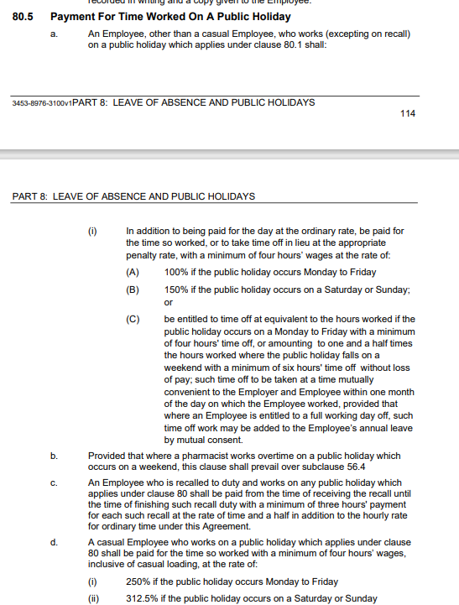

working on a public holiday- Night Duty

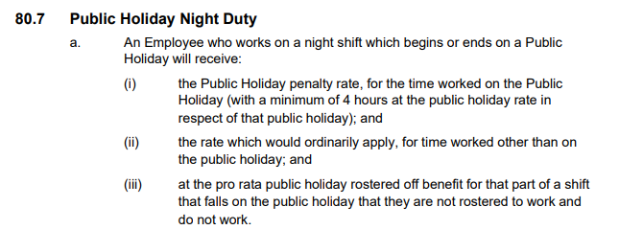

not working on a public holiday – FULL TIME
Relevant Clause
Note: The definition of Actual Day and Other Day can be found summarised below under Additional Rules – Public Holidays falling on a Weekend

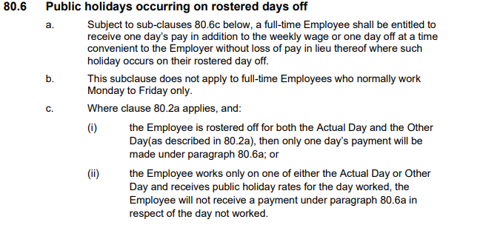

not working on a public holiday – Part TIME
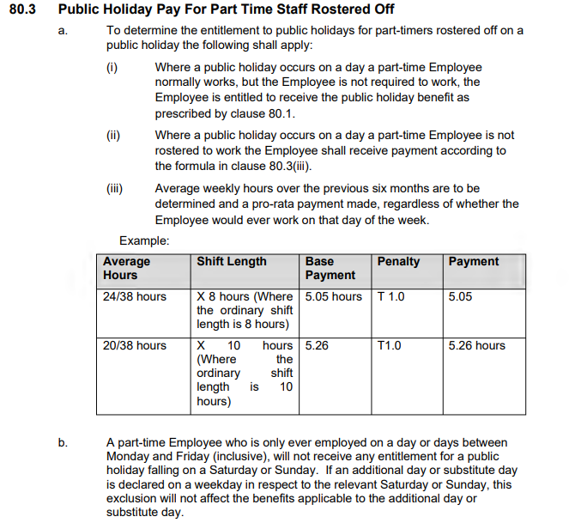

additional rules – public holidays falling on weekend
Relevant Clause

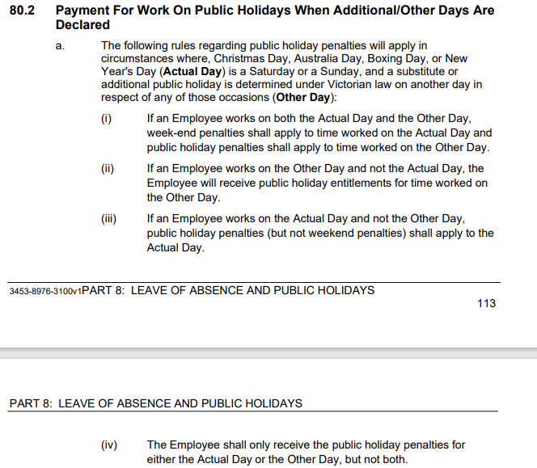

additional rules – other leave on public holidays
Leave Type | Impact of taking leave on a Public Holiday
Annual Leave | The annual leave prescribed in clause 61.2 shall be exclusive of any of the holidays prescribed by clause 80 - Public holidays, and if any such holiday falls within an Employee’s period of annual leave and is observed on a day which in the case of that Employee would have been an ordinary working day there shall be added to the period of annual leave time equivalent to the ordinary time which the Employee would have worked if such day had not been a holiday– see sub-clause 61.3
Personal Leave | If the period during which an Employee takes paid personal/carer’s leave includes a day or part-day that is a public holiday in the place where the Employee is based for work purposes, the Employee is taken not to be on paid personal/carer’s leave on that public holiday, but will be entitled to the ordinary time public holiday payment as per the provisions of this Agreement– see sub-clause 64.3
Long Service Leave | Long service leave is inclusive of any public holiday occurring during the period when leave is taken - see sub-clause 67.8
Paid Parental Leave | An Employee on Paid Parental Leave when a public holiday occurs does not receive a public holiday entitlement, nor does it extend the Paid Parental Leave period
Unpaid Leave | If an employee is on Unpaid Leave when a Public Holiday occurs, the employee does not receive a public holiday entitlement.

additional rules – recall on public holiday
Relevant Clause
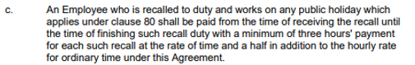

Table 1: Summary of Public Holiday Entitlements

Full Time | Entitlement | Clause Ref.
Rostered to Work (works on public holiday) | 200% or 250% if it falls on a Saturday or Sunday  or  1 days ordinary pay + entitled to time off equivalent to the hours worked on the public holiday (to be taken off within 4 weeks of the public holiday worked) or added to employee’s A/L by mutual consent | 80.5
Rostered to Work (not required to work) | 1 days ordinary pay at the rostered hours for that day | 80.1
Not Rostered to Work (rostered day off) | 1 days ordinary pay (7.6 hours unless the employee ordinarily works longer shifts) or 1 day TIL  Weekend PH (including Easter Saturday)  As above, but not payable to employees who only work Monday to Friday. | 80.6

Part Time | Entitlement | Clause Ref.
Rostered to Work (works on public holiday) | 200% or 250% if it falls on a Saturday or Sunday  or  1 days ordinary pay + entitled to time off equivalent to the hours worked on the public holiday (to be taken off within 4 weeks of the public holiday worked) or added to employee’s A/L by mutual consent | 80.5
Rostered to Work (not required to work) | 1 days ordinary pay at the rostered hours for that day | 80.1
Not Rostered to Work (rostered day off) | Weekdays & Weekend PH (including Easter Saturday)  Pro-rata payment, equal to their ordinary pay for the average daily hours worked by that employee over the previous six months (e.g. 24  /38 x 8 hours (or usual shift length) = 5.05 hours.  A part-time Employee who is only ever employed on a day or days between Monday and Friday (inclusive), will not receive any entitlement for a public holiday falling on a Saturday or Sunday | 80.3  80.3(b)

Casual | Entitlement | Clause Ref.
Rostered to Work | 250% or 312.5% if it falls on a Saturday or Sunday | 80.6(d)
Not Rostered to Work | No rostered off benefit unless they are required to work on that day | Silent

Table 2: public holidays OCCURING until nominal expiry date
Note: Public Holidays falling on a weekend are marked in bold

2024
New Years Day – 1 January 2024 | Australia Day – 26 January 2024
Labour Day – 11 March 2024 | Good Friday – 29 March 2024
Saturday before Easter Saturday – 30 March 2024 | Easter Sunday – 31 March 2024
Easter Monday -1 April 2024 | ANZAC Day – 25 April 2024
King’s Birthday – 10 June 2024 | Friday before AFL Grand Final – 27 September 2024
Melbourne Cup – 5 November 2024 | Christmas Day – 25 December 2024
Boxing Day – 26 December 2024
Source - Victorian public holidays 2024 | Business Victoria

2025
New Years Day – 1 January 2025 | Australia Day – 26 January 2025 (A) & 27 January 2025 (O)
Labour Day – 10 March 2025 | Good Friday – 18 April 2025
Saturday before Easter Saturday – 19 April 2025 | Easter Sunday – 20 April 2025
Easter Monday – 21 April 2025 | ANZAC Day – 25 April 2025
King’s Birthday – 9 June 2025 | Friday before AFL Grand Final – TBC
Melbourne Cup – 4 November 2025
Source: Victorian public holidays 2025 | Business Victoria

Melbourne Cup Day is a public holiday across all of Victoria unless alternate local holiday has been arranged by a non-metro council.

